AI Use Declaration Form
Course: Introduction to Artificial Intelligence
Lab Title: Lab 1 Part A — Uninformed Search Algorithms
Student Name: Vincent Chanayire
Student ID: 25262028
GitHub Repository Link: https://github.com/hswee200/ai_Labs.git
Date Submitted: Saturday 20th June

1. AI Use Summary
Question | Student Response
Did you use any AI tool for this lab? | Yes
Estimated percentage of the work influenced by AI | 30%
Did you attach evidence of AI use where applicable? | Yes

2. Details of AI Use
Complete the table below for each AI tool used. Add more rows where necessary.
Name of AI Tool Used | Purpose for Using the Tool | Prompt or Instruction Given to the Tool | Part(s) of the Work Influenced by the Tool | How I Verified, Edited, or Improved the AI Output
Chat Gpt | To understand informed search concepts, debug code, and clarify algorithm behaviour | i have gotten confused to simply explain all what we have done up until now explain are goal and hwo we are planing on getting there, why we did it what was its result, how it did it how it can change what were the options what would have happened if we did eg. A instead of B. do this simply but deeply | Lab 1 Part A (BFS, DFS, DLS, IDS, reached list, search trees, reflection questions)  BestFirstSearch implementation, Greedy Best-First Search, A*, Weighted A*, heuristic functions, reflection questions, debugging | I cross-checked explanations with lecture notes, the lab handout, and experimental results from my notebook before using them.

3. Attachment of AI Output Evidence
Where required, attach evidence of AI use. Tick all that apply. Add more rows where necessary.
Evidence Type | Attached? (Yes, No, N/A) | File Name
AI-generated draft | No
Prompt history | Yes
Screenshot of AI interaction | Yes
Exported AI conversation | No
AI-generated code snippet | Yes
Revised version showing student input | No

4. Student Declaration
I declare that:
Declaration Statement | Response (Yes/No)
The submitted work is my own work. | Yes
Any use of AI tools has been clearly declared in this form. | Yes
The prompts, instructions, and AI-generated outputs have been disclosed where applicable. | Yes
I reviewed, tested, edited, and improved any AI-generated content before submission. | Yes
My AI usage does not exceed 25% of the entire work. | No
I understand that undeclared or excessive AI use may be treated as academic misconduct. | Yes

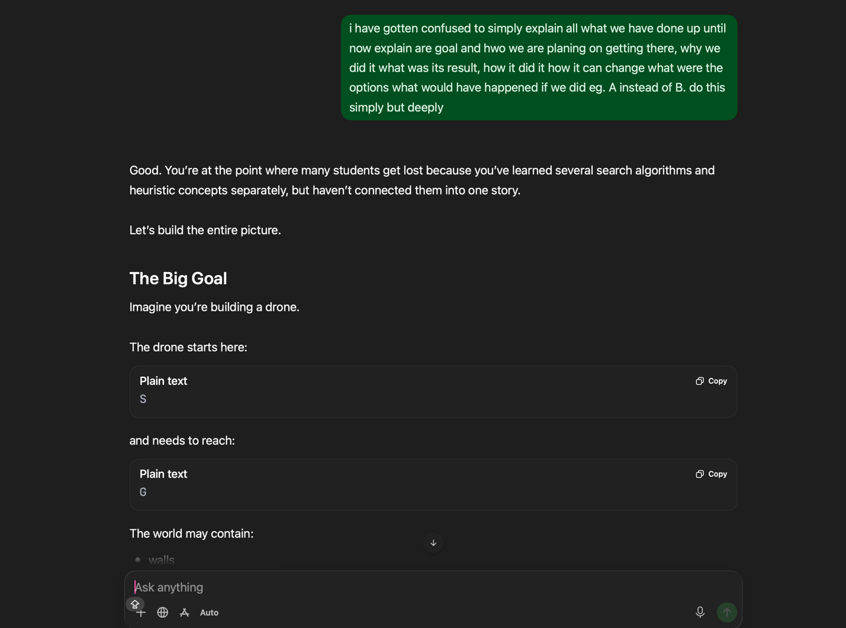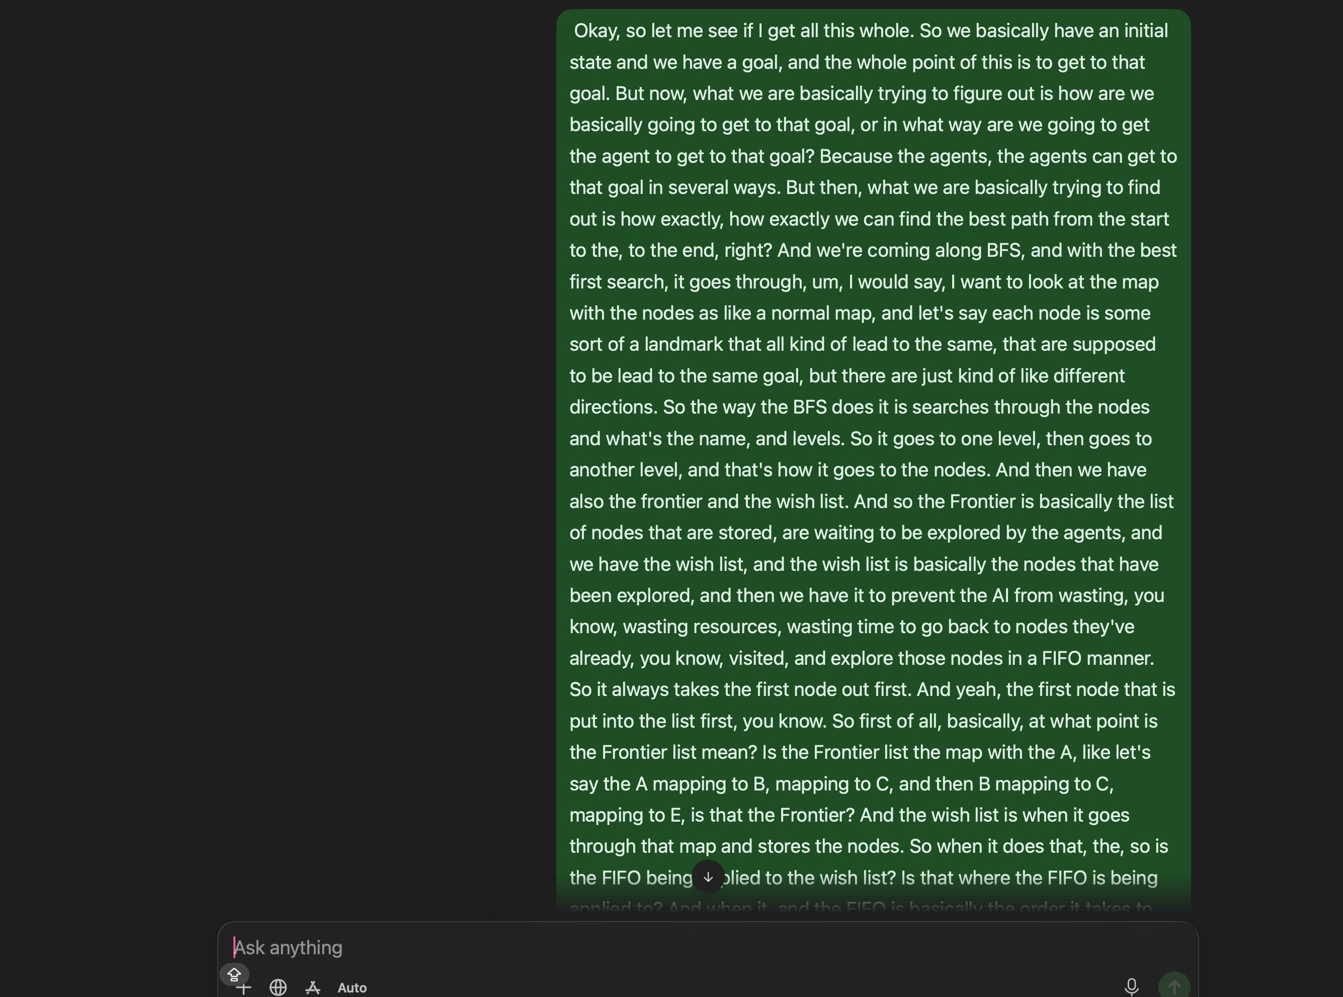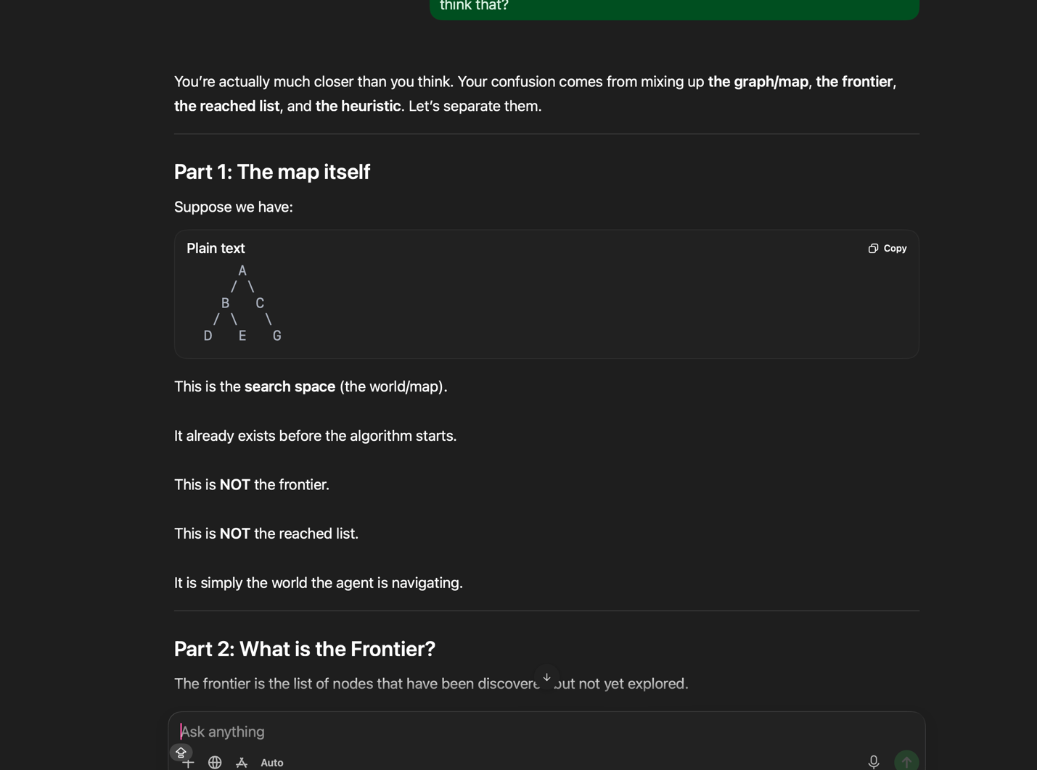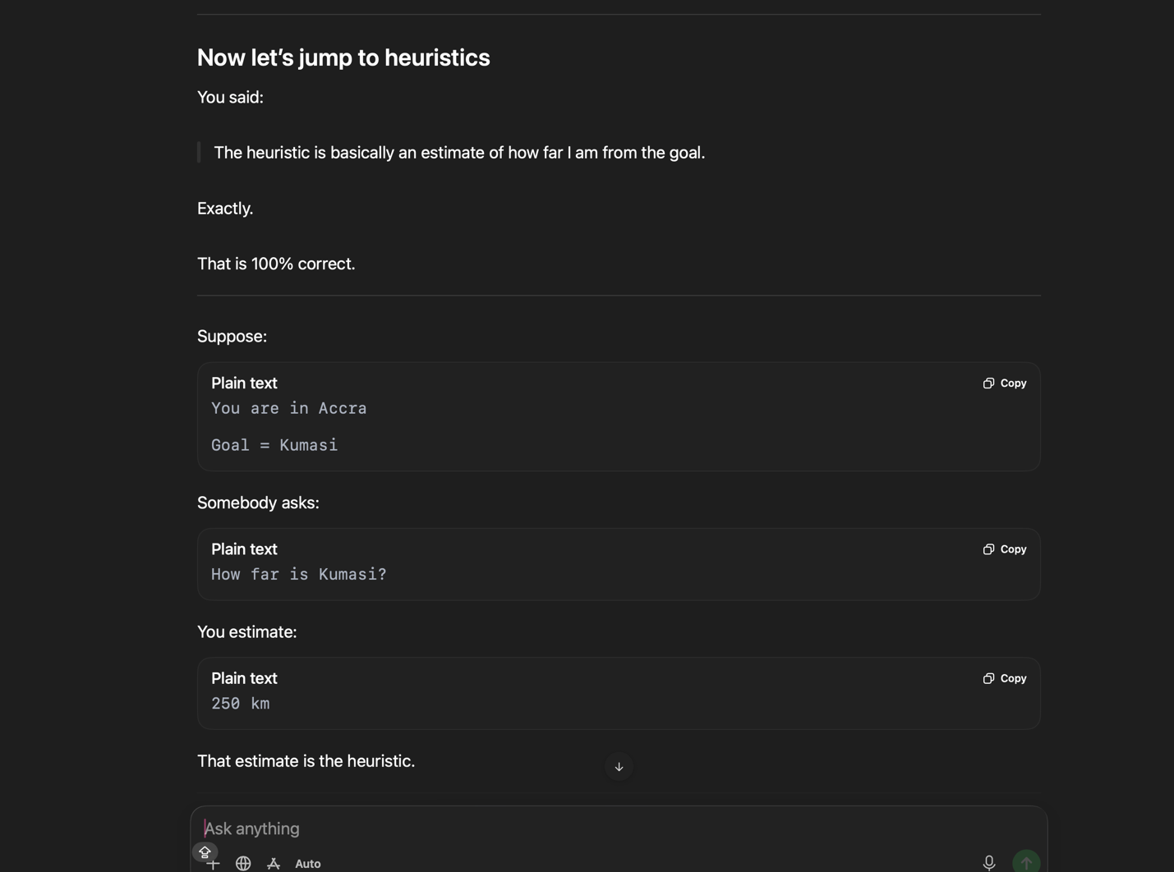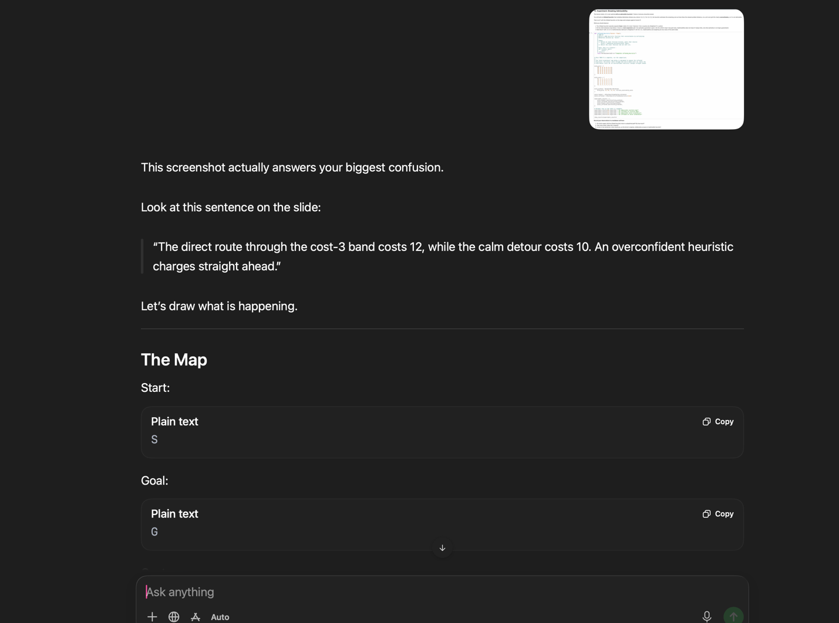

Student Signature: VAC
Date: 20 June 2026

